# CS 255 System Design Document

## UML Diagrams

### UML Use Case Diagram

### UML Activity Diagrams

### UML Sequence Diagram

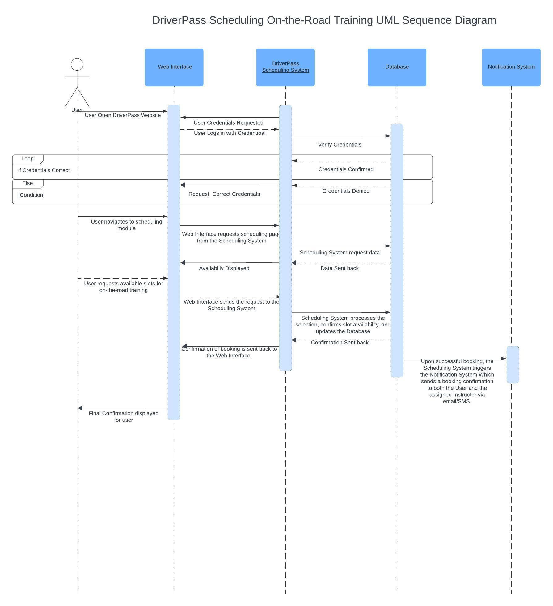

### UML Class Diagram

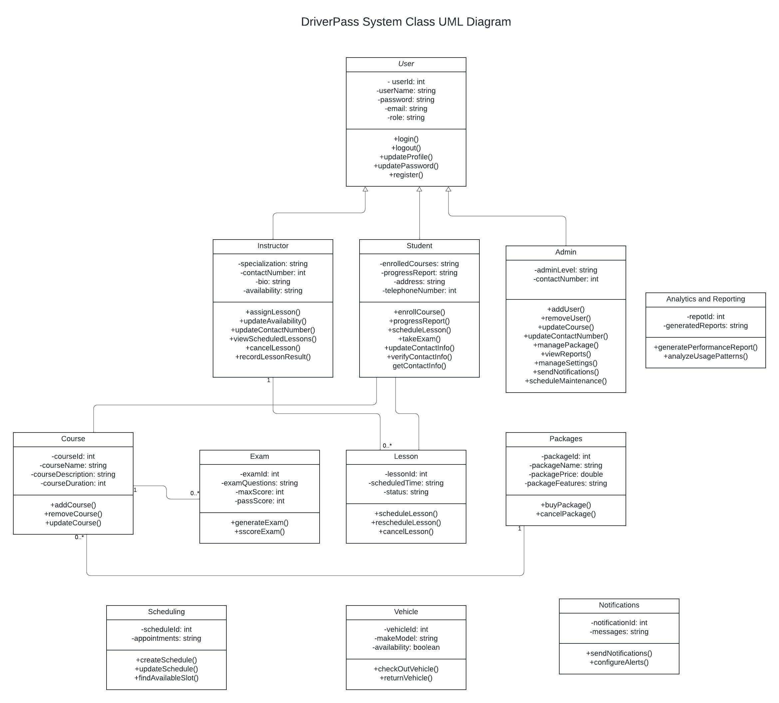

## Technical Requirements

**Hardware Requirements**

1. **Servers**: Multi-core processors, at least 16 GB RAM, and adequate SSD storage for web and database services.
2. **Workstations**: Desktops or laptops with at least 8 GB RAM and modern processors for administrative and development tasks.
3. **Mobile Devices**: Smartphones or tablets with modern specifications for mobile accessibility testing.

**Software Requirements**

1. **Operating Systems**: Windows Server 2019 or newer, or Linux distributions like Ubuntu 20.04.
2. **Database Management System (DBMS)**: PostgreSQL or MySQL for robust data handling.
3. **Web Server Software**: Apache or Nginx to host web applications and manage high traffic.
4. **Development Frameworks**: .NET or Django for development, depending on platform compatibility.
5. **Frontend Technologies**: HTML5, CSS3, JavaScript, with frameworks such as React or Angular.

**Tools and Libraries**

1. **Integrated Development Environment (IDE)**: Visual Studio, Eclipse, or similar.
2. **Version Control System**: Git for source code management.
3. **Project Management Tools**: JIRA, Trello, or Asana for task tracking and milestone management.

**Infrastructure Requirements**

1. **Cloud Services**: AWS, Google Cloud, or Azure for hosting, scalability, and performance monitoring.
2. **Network Infrastructure**: High bandwidth and low latency internet connectivity.

**Security and Compliance**

1. **Data Transmission Security**: SSL/TLS for secure data transmission.
2. **Compliance**: Adherence to GDPR, HIPAA, or other relevant data protection regulations.
3. **Backup and Recovery**: Systems for data backup and efficient recovery processes.

**Integration and Support Systems**

1. **APIs**: For integration with DMV databases and payment gateways.
2. **Support System**: Implementation of a helpdesk or customer support system for user assistance.

**Maintenance and Continuous Improvement**

1. **System Monitoring Tools**: For continuous performance and security monitoring.
2. **CI/CD Tools**: For automated testing and deployment to minimize downtime and errors.